SIMATS ENGINEERING
Department of Computer Science & Engineering
ASSESSMENT TOOL 1- EXPERIMENTS

Course Code: | CSA1205 | Course Title: | Computer Architecture for Multicore Systems
CO Assessed: | CO3 | Assessment: | ASSESSMENT TOOL 1- EXPERIMENTS
Weightage: | 40% | Total Marks: | 25
CO3 Statement: | Design processor organization by constructing pipelined datapath structures, identifying hazard types (data, control, structural), and comparing superscalar techniques such as out-of-order execution, speculative execution, and simultaneous multithreading (SMT). (BL6)
Student Name: | VIJAYALAKSHMI S | Reg.No.: | 192472326
Department: | CSE -AI | Date: | 14/08/2026

ANNEXURE A
- Design and simulate a system that performs register transfer operations along with basic arithmetic and logic operations such as addition, subtraction, AND, and OR. Use multiple registers to demonstrate how data is transferred between them during execution, and analyze the sequence of operations and the role of the ALU in processing data.
- Create a model of a computer system using single-bus and multi-bus organization, and perform data transfer operations between registers, memory, and I/O. Compare the time taken and efficiency of both approaches, and analyze how multiple bus structures improve parallel data transfer and reduce bottlenecks.
- Simulate a 5-stage instruction pipeline (Fetch, Decode, Execute, Memory, Write-back) and execute a set of instructions. Measure the performance in terms of speedup and throughput, and compare it with a non-pipelined system to evaluate the effectiveness of pipelining.
- Develop a pipeline execution scenario where data hazards, control hazards, and structural hazards occur. Observe their impact on instruction execution, and implement techniques such as stalling, data forwarding, and branch prediction to resolve these hazards and improve performance.
- Analyze a processor supporting superscalar execution, including out-of-order and speculative execution, and extend the study to include hyper-threading and simultaneous multithreading (SMT). Evaluate how multiple instructions are executed in parallel and compare the performance improvements in terms of instruction throughput and resource utilization.

Code of Conduct:

I VIJAYALAKSHMI S (192472326) (Name / Reg No) certify that this submission is my original work and that I have adhered to the guidelines specified for this assessment.I understand that any violation of academic integrity rules will result in disciplinary action.

Signature of the student: VIJAYALAKSHMI S
MARKS ALLOCATION
 | Understanding of Concepts (20%) | Experimental Design (20%) | Use of Tools (25%) | Analysis of Results (20%) | Documentation (15%)
Q1
Q2
Q3
Q4
Q5

RUBRICS FOR CALCULATION:

Criteria | Weightage | Level 4 – Exemplary | Level 3 – Proficient | Level 2 – Developing | Level 1 – Beginning
Understanding of Concepts | 25 | Demonstrates thorough understanding and effectively integrates multiple concepts/technologies | Good understanding with proper integration of most concepts | Basic understanding; limited or partial integration | Poor understanding; unable to integrate concepts
Experimental Design | 30 | Well-planned, systematic implementation with optimal solution | Correct implementation with minor issues | Basic implementation with errors or inefficiencies | Incorrect or incomplete implementation
Use of Tools | 20 | Effective and advanced use of tools/technologies with proper configuration | Appropriate use of tools with correct execution | Limited or inconsistent use of tools | Incorrect or minimal use of tools
Analysis of Results | 15 | Insightful analysis with accurate interpretation and validation of results | Good analysis with reasonable interpretation | Basic analysis with limited insights | Poor or incorrect analysis of results
Documentation | 10 | Clear, well-structured documentation with diagrams, code, and results | Organized documentation with necessary details | Basic documentation with missing details | Poor or incomplete documentation

Q1. Register Transfer Operations and ALU
Aim
To design and simulate register transfer operations and basic ALU operations such as addition, subtraction, AND, and OR using Python.
Algorithm
- Start the program.
- Read the values of registers R1 and R2.
- Display the register values.
- Display the available ALU operations.
- Get the user's choice.
- Perform the selected operation using R1 and R2.
- Store the result in register R3.
- Display the result.
- Stop the program

PROGRAM CODE
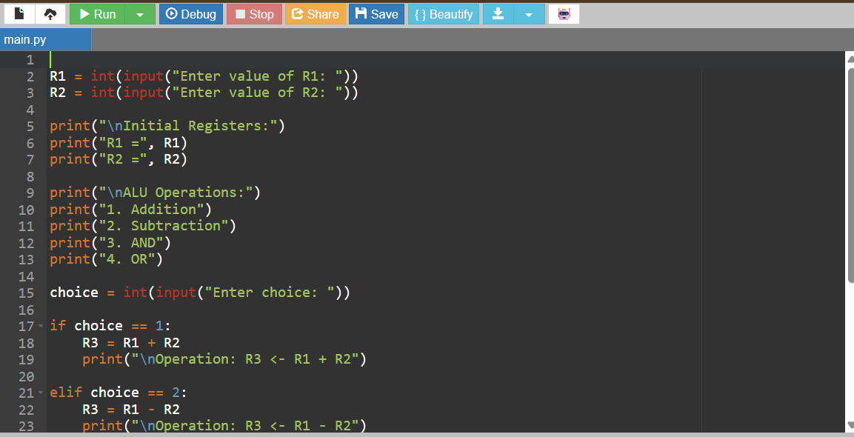

SAMPLE INPUT AND OUTPUT

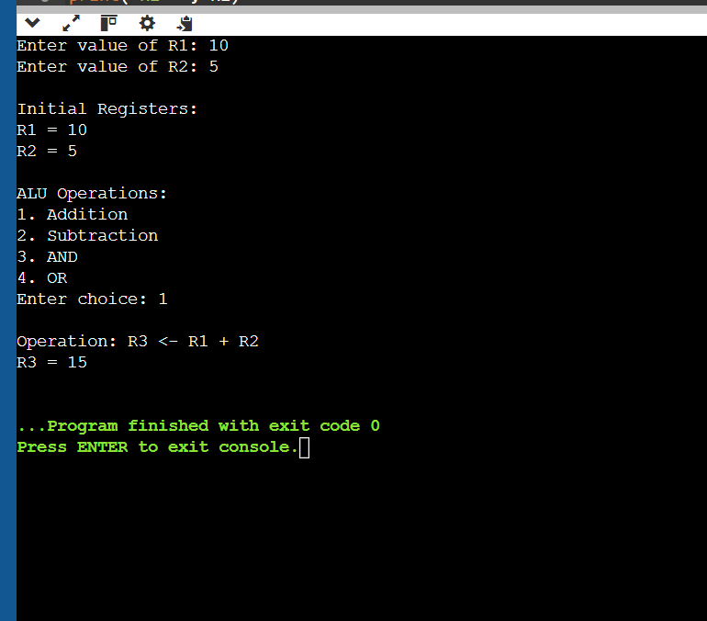
Result
Thus, the register transfer operations and basic ALU operations such as addition, subtraction, AND, and OR were successfully simulated using Python.

Q2. Single-Bus and Multi-Bus Organization
Aim
To simulate single-bus and multi-bus organization and compare their data transfer cycles and efficiency using Python.
Algorithm
- Start the program.
- Read the values of registers R1 and R2.
- Simulate single-bus organization.
- Transfer R1 and R2 through the bus to the ALU.
- Perform the addition and store the result in R3.
- Count the number of cycles required.
- Simulate multi-bus organization.
- Transfer R1 and R2 simultaneously to the ALU.
- Store the ALU result in R3.
- Compare the number of cycles for both organizations.
- Display the faster organization.
- Stop the program.

PROGRAM CODE
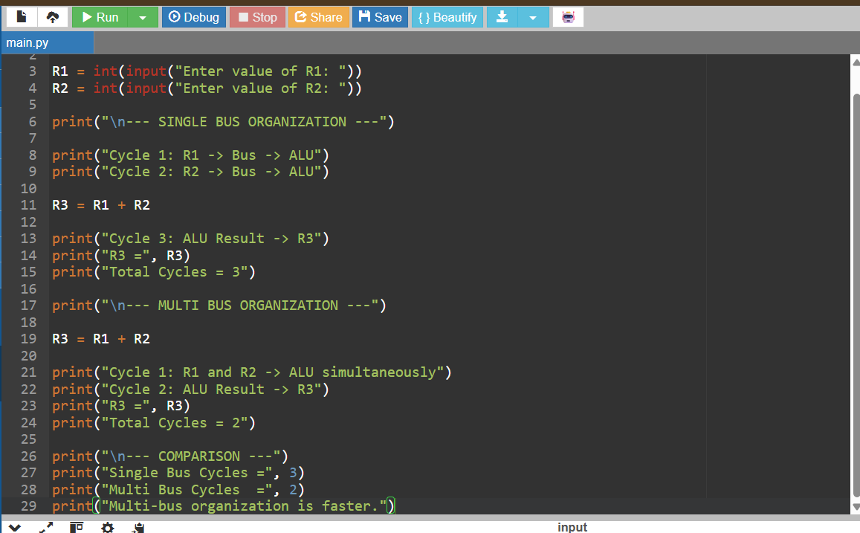

SAMPLE INPUT AND OUTPUT
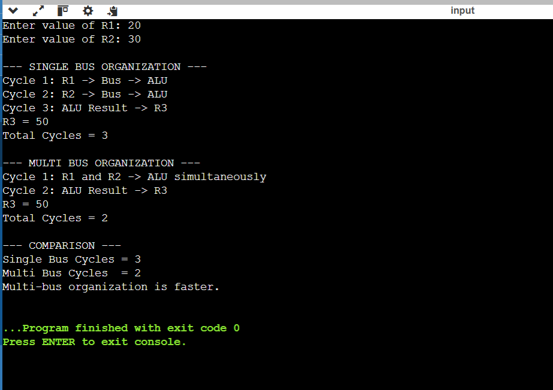
Result
Thus, single-bus and multi-bus organizations were successfully simulated. The multi-bus organization required fewer clock cycles because it supports parallel data transfer.

Q3. 5-Stage Instruction Pipeline
Aim
To simulate a 5-stage instruction pipeline consisting of Fetch, Decode, Execute, Memory, and Write Back stages and calculate the performance improvement.
Algorithm
- Start the program.
- Read the number of instructions.
- Define the five pipeline stages:
  - Fetch
  - Decode
  - Execute
  - Memory
  - Write Back
- Simulate the execution of instructions through the pipeline.
- Calculate pipelined execution cycles using:
Pipeline cycles = Number of instructions + 4
- Calculate non-pipelined cycles using:
Non-pipelined cycles = Number of instructions × 5
- Calculate speedup.
- Display the pipeline execution and performance.
- Stop the program.
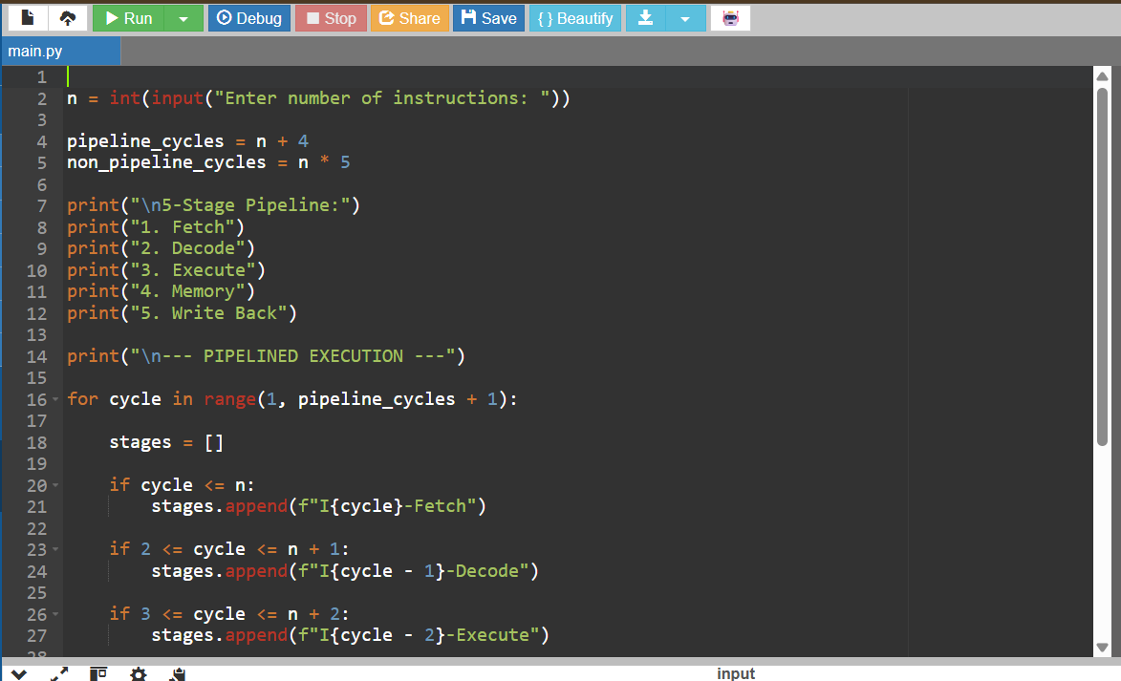

SAMPLE INPUT AND OUTPUT
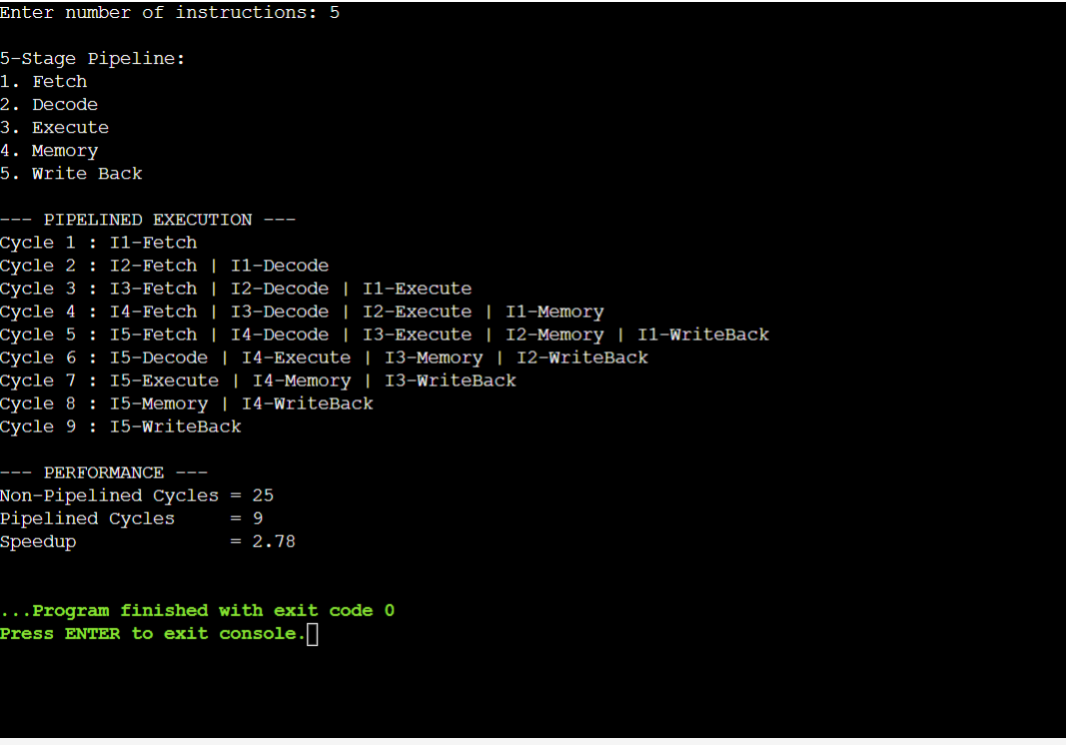
Result
Thus, the 5-stage instruction pipeline was successfully simulated. Pipelining reduced the total execution time and improved the instruction throughput compared with non-pipelined execution.

Q4. Pipeline Hazards
Aim
To simulate different types of pipeline hazards, namely data, control, and structural hazards, and demonstrate techniques such as stalling, data forwarding, and branch prediction.
Algorithm
- Start the program.
- Display the three types of pipeline hazards.
- Get the user's choice.
- If Data Hazard is selected:
  - Identify dependency between instructions.
  - Demonstrate stalling.
  - Demonstrate data forwarding.
- If Control Hazard is selected:
  - Identify a branch instruction.
  - Demonstrate branch prediction.
- If Structural Hazard is selected:
  - Identify two instructions requiring the same resource.
  - Demonstrate stalling or resource duplication.
- Display the solution for the selected hazard.
- Stop the program.
PROGRAM CODE:
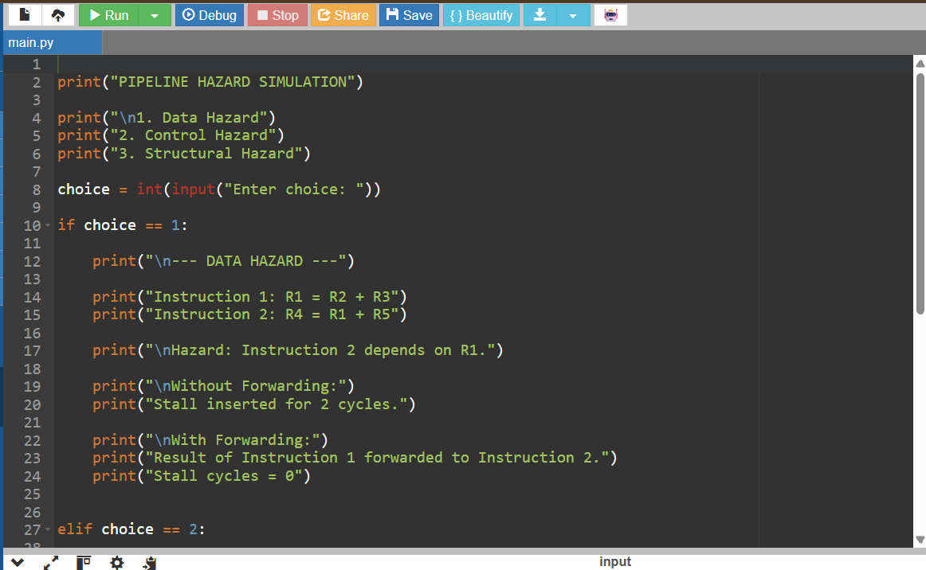

SAMPLE INPUT AND OUTPUT
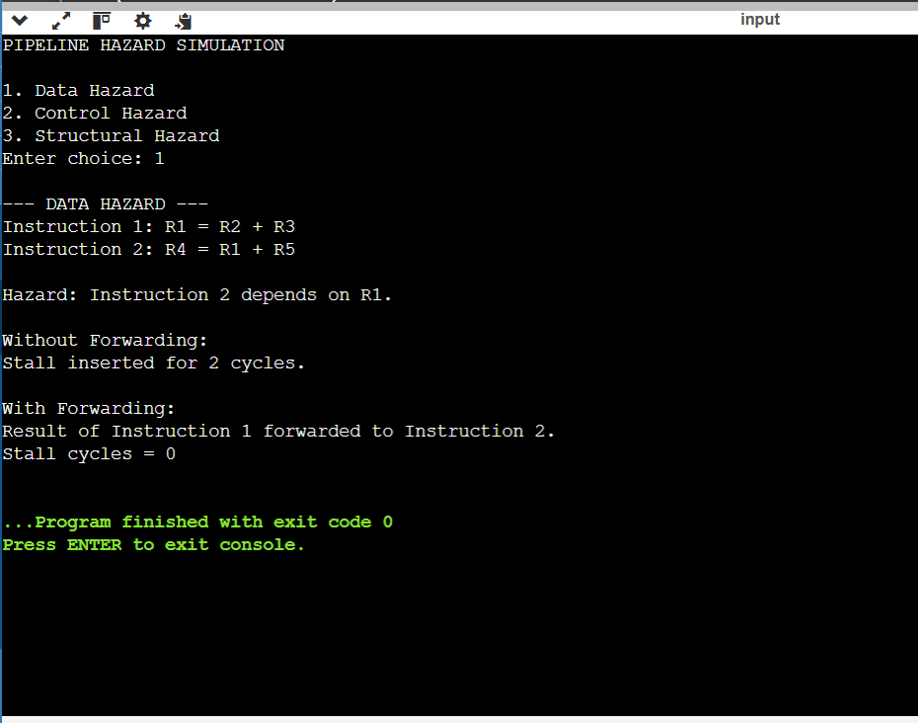
Result
Thus, data, control, and structural pipeline hazards were successfully simulated, and techniques such as stalling, data forwarding, and branch prediction were demonstrated to reduce their impact on performance.

Q5. Superscalar, Out-of-Order, Speculative Execution and SMT
Aim
To simulate superscalar execution, out-of-order execution, speculative execution, and simultaneous multithreading (SMT) and analyze their effect on instruction throughput.
Algorithm
- Start the program.
- Read the number of instructions.
- Simulate superscalar execution by executing two instructions in parallel.
- Calculate the number of cycles required.
- Demonstrate out-of-order execution by executing independent instructions first.
- Demonstrate speculative execution using branch prediction.
- Demonstrate SMT by showing multiple instruction streams sharing processor resources.
- Calculate the speedup compared with normal execution.
- Display the performance results.
- Stop the program.
PROGRAM CODE
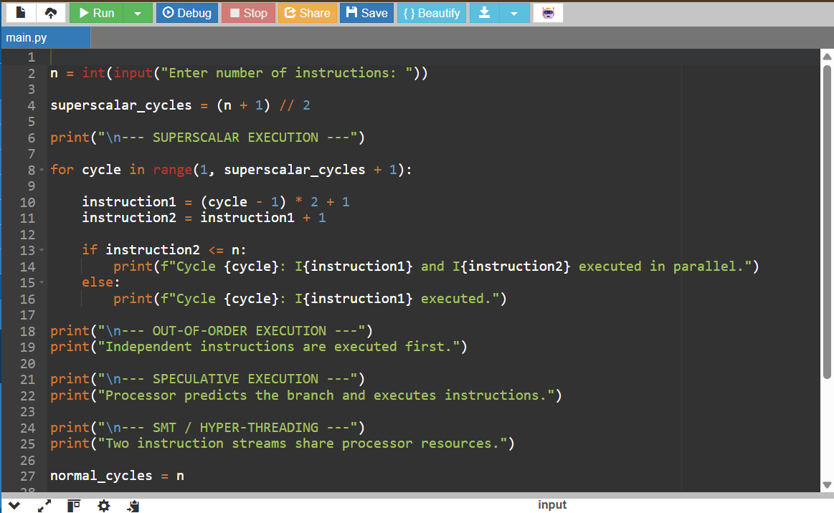

SAMPLE INPUT AND OUTPUT
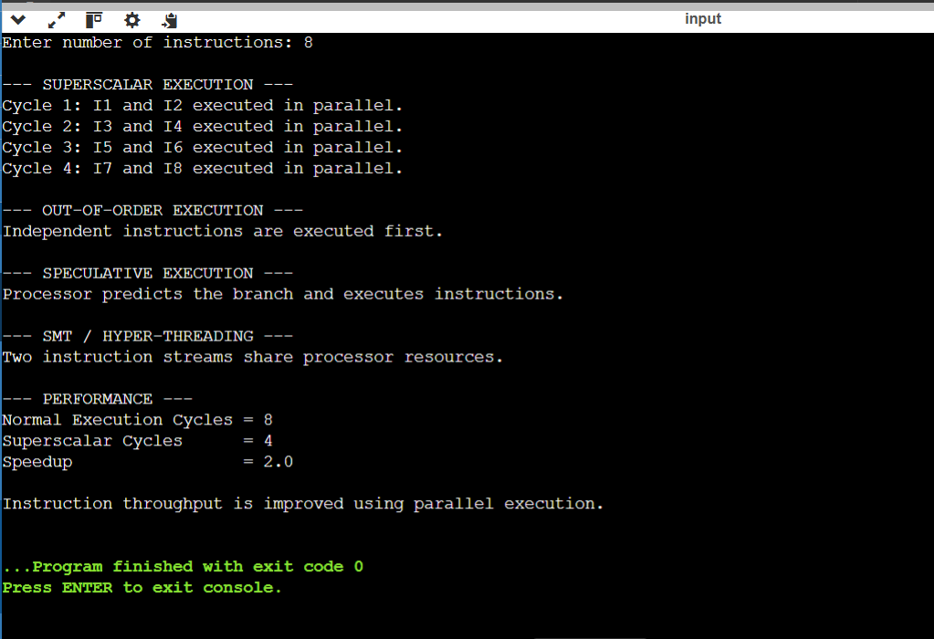
Result
Thus, superscalar, out-of-order, speculative execution, and SMT were successfully simulated. Parallel execution improved instruction throughput and processor resource utilization compared with normal sequential execution.

